**MSBA 250 — Applied Business Analytics**

**University of the Pacific**

**Spring 2024**

**Assignment 5**

**Due: Saturday April 27, 2024**

Instructions:

This homework set has 2 Problems. The total credit for this homework set is 20.

Please write down your name, ID, and section number on the upper-right corner of the paper.

**Problem 1: (5 Points)**

Universal Claims Processors processes insurance claims for large national insurance companies.

Most claim processing is done by a large pool of computer operators, some of whom are permanent and some of whom are temporary. A permanent operator can process 14 claims per day, whereas a temporary operator can process 12 per day, and on average the company processes at least 300 claims each day. The company has 40 computer workstations. A permanent operator generates about 0.5 claim with errors each day, whereas a temporary operator averages about 2.3 defective claims per day. The company wants to limit claims with errors to 20 per day. A permanent operator is paid $46 per day, and a temporary operator is paid $15 per day. The company wants to determine the number of permanent and temporary operators to hire in order to minimize costs.

1. Write down the objective function of the linear programming model for this problem.

X1: number of permanent operators

X2: number of temporary operators

Minimize Z = (labor cost, $)

1. Write down the constraints of the linear programming model for this problem.

Claim Processing:

Operator Availability:

Error Rate Limit:

Non-negativity:

**Problem 2: (5 Points)**

For the following Linear Programming model.

Minimize *Z* = 15*x*1 + 9*x*2

subject to

8*x*1 + 6*x*2 ≥ 48

*x*1 + 2*x*2 ≥ 12

*x*1, *x*2 ≥ 0

Please use Excel Solver to find the optimal solutions and the optimal objective function value.

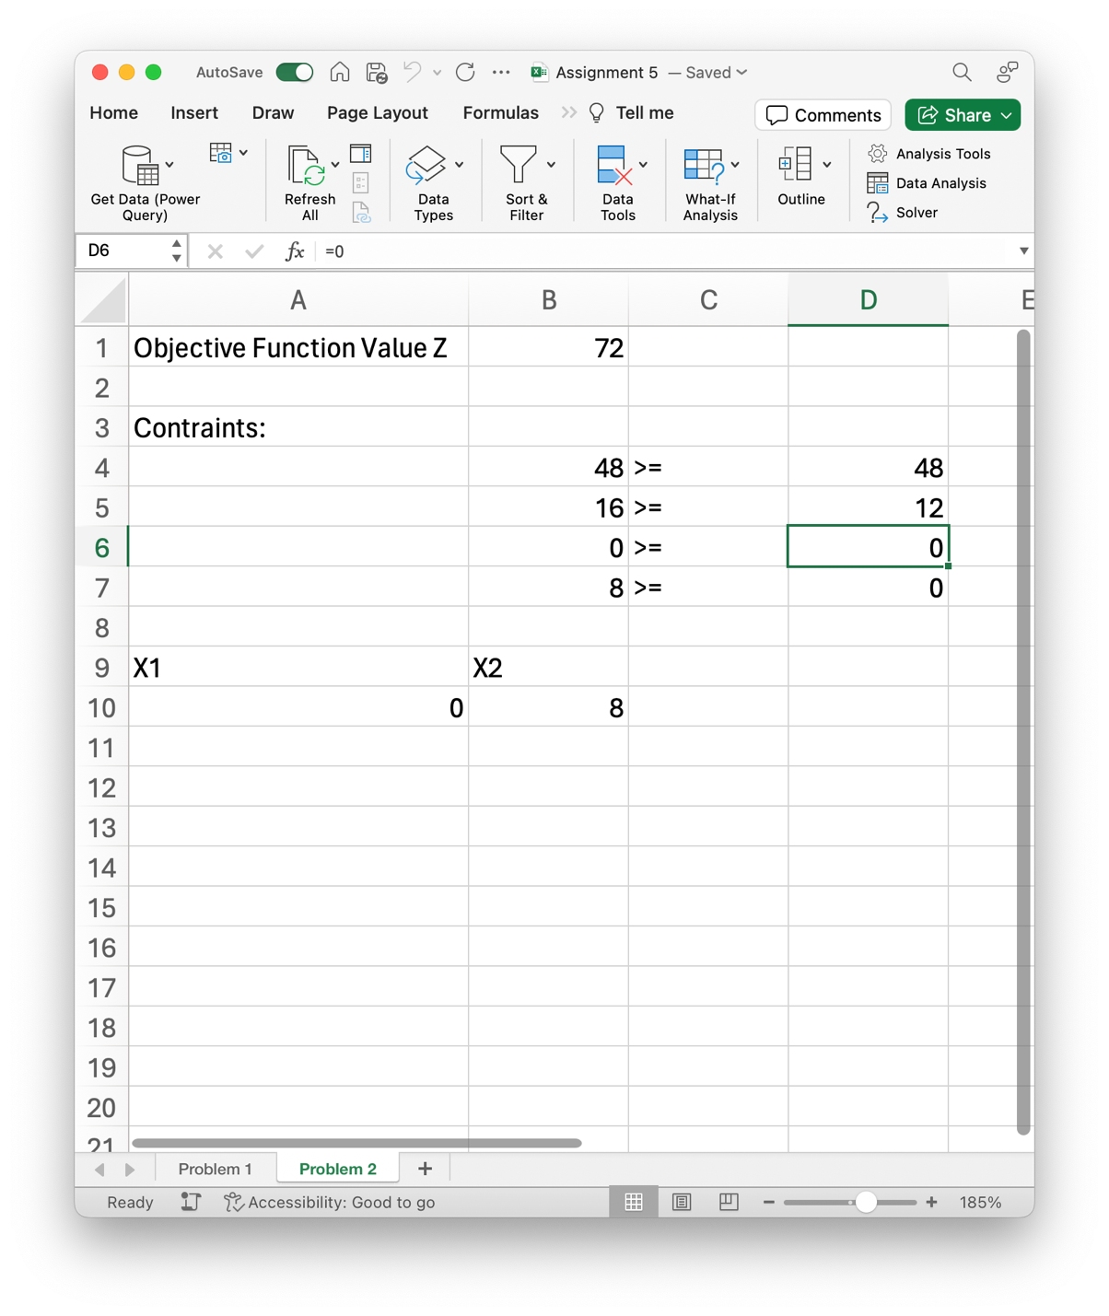

**Problem 3: (5 Points)**

The Kreeger Grocery Store chain has bought out a competing grocery store chain. However, it now has too many stores in close proximity to each other in certain cities. In Roanoke, the chain has 10 stores, and it does not want any stores closer than 2 miles to each other. The following are the monthly revenues ($1,000s) from each store and a map showing the general proximity of the stores. Stores within 2 miles of each other are circled. Formulate an integer programming model to determine which stores the Kreeger chain should keep open in Roanoke to maximize its profits.

Maximize:

**Problem 4 (5 Points)**

Please find the EXCEL file “Students.” Please find and visualize for students with different gender and test preparation course status, whether their math scores are the same. If not, is there any pattern you find? Please use Tableau to analyze and visualize. Then please have a brief discussion about your analysis and findings.

Students with different genders and test preparation course statuses do not have the same math scores. Male students score higher than female students in both categories of the Test Preparation Course (completed and none). Overall, those who had completed the course score. The total math score of students who had completed the course is lower than the ones did not regard of gender.

